|  |  |
| --- | --- |
| **Ex.No:5.B** | **Binary Search** |
|  |

***Aim:***

To develop a python program to perform binary search in a list of numbers.

***Algorithm:***

|  |  |
| --- | --- |
| **Step 1:** | Start Process |
| **Step 2:** | Get a list of numbers from user and store id alist. |
| **Step 3:** | Get a number to be searched from user and assign to key. |
| **Step 4:** | Assign found as False |
| **Step 5:** | Assign start as 0 and end as length of list – 1 |
| **Step 6:** | Compute mid by getting floor average from start and end |
| **Step 7:** | If mid index element is equals to key then set found as True and goto Step |
| **Step 8:** | Else compare key with mid index element |
| **Step 9:** | If key is less than mid index element then assign end as mid – 1 goto Step 11 |
| **Step 10:** | Else assign start as mid + 1 goto Step 11 |
| **Step 11:** | If start is less than or equal to end and found is not True then goto Step 6 |
| **Step 12:** | Else goto Step 13 |
| **Step 13:** | If found is True then print “Element found” and goto Step 15 |
| **Step 14:** | Else print “Element not Found” |
| **Step 15:** | Stop Process |

**Flow Chart:**

**Flow Chart:**

**Pseudo Code:**

START

READ alist

READ key

ASSIGN found = FALSE

ASSIGN start = 0

ASSIGN end = length of alist - 1

WHILE start <= end and not found

mid = (start + end)/2

IF alist[mid] is equals to key THEN

found = TRUE

ELSE

IF key is less than alist[mid] THEN

end = mid – 1

ELSE

Start = mid + 1

END IF

END IF

END WHILE

IF found equals to TRUE

PRINT “Element found”

ELSE

PRINT “Element not Found”

END IF

STOP

**Program:**

print("Binary Search")

print("-----------------")

alist = []

print ("enter any 5 numbers")

for i in range(5):

data = int(input())

alist.append(data)

key = int(input("Enter any number to search"))

found = False

start = 0

end = len(alist)-1

while(start<=end and not found):

mid = (start+end)//2

if (key == alist[mid]):

found = True

else:

if (key < alist[mid]):

end = mid-1

else:

start = mid+1

if(found):

print("Element Found")

else:

print("Element not Found")

**Output:**

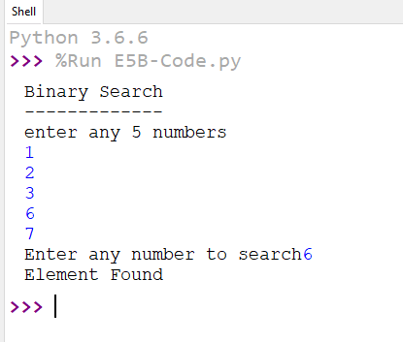

***Result:***

Thus the program to perform binary search in a given list was developed and tested successfully.